Test Levels and Test Types
# Source: AI Source: Provided by: [Data Path: Persons Table -> ID Column: 1, Name_En Column: Motasem Essam] -> From: [ChatGPT] on [8/21/2025]
Alright — let’s go deep into Test Levels and Test Types because these are fundamental in understanding how testing is structured in software development.

1. Test Levels — "When and where we test in the development cycle"
# Source: AI Source: Provided by: [Data Path: Persons Table -> ID Column: 1, Name_En Column: Motasem Essam] -> From: [ChatGPT] on [8/21/2025]
Test levels describe the scope and stage of testing. Each level focuses on a different part of the system.

Main Test Levels
# Source: AI Source: Provided by: [Data Path: Persons Table -> ID Column: 1, Name_En Column: Motasem Essam] -> From: [ChatGPT] on [8/21/2025]
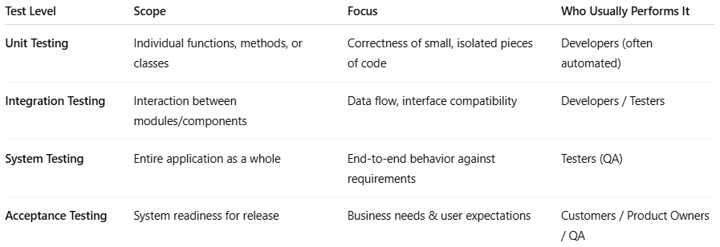
Test Level | Scope | Focus | Who Usually Performs It
Unit Testing | Individual functions, methods, or classes | Correctness of small, isolated pieces of code | Developers (often automated)
Integration Testing | Interaction between modules/components | Data flow, interface compatibility | Developers / Testers
System Testing | Entire application as a whole | End-to-end behavior against requirements | Testers (QA)
Acceptance Testing | System readiness for release | Business needs & user expectations | Customers / Product Owners / QA

Details of Each Level
# Source: AI Source: Provided by: [Data Path: Persons Table -> ID Column: 1, Name_En Column: Motasem Essam] -> From: [ChatGPT] on [8/21/2025]
- Unit Testing
  - Smallest testable parts of the application.
  - Example: Testing a calculateTotal() function.
  - Tools: JUnit, NUnit, pytest.
- Integration Testing
  - Checks whether different parts/modules work together.
  - Can be:
    - Big Bang (all modules together)
    - Incremental (step-by-step integration)
  - Example: Verifying if the payment module correctly interacts with the order module.
- System Testing
  - Tests the whole system in an environment close to production.
  - Includes functional and non-functional checks.
  - Example: Testing an entire e-commerce site from browsing products to checkout.
- Acceptance Testing
  - Confirms the system meets business requirements.
  - Often written in business language (e.g., Gherkin for BDD/ATDD).
  - Example: "Given I add a product to the cart, When I check out, Then I should see a confirmation email."

2. Test Types — "What kind of quality aspect we are testing"
# Source: AI Source: Provided by: [Data Path: Persons Table -> ID Column: 1, Name_En Column: Motasem Essam] -> From: [ChatGPT] on [8/21/2025]
Test types describe the purpose or goal of a test, regardless of when it happens.

Main Test Types
# Source: AI Source: Provided by: [Data Path: Persons Table -> ID Column: 1, Name_En Column: Motasem Essam] -> From: [ChatGPT] on [8/21/2025]
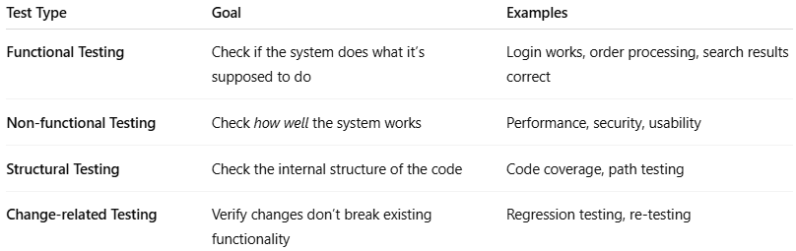
Test Type | Goal | Examples
Functional Testing | Check if the system does what it’s supposed to do | Login works, order processing, search results correct
Non-functional Testing | Check how well the system works | Performance, security, usability
Structural Testing | Check the internal structure of the code | Code coverage, path testing
Change-related Testing | Verify changes don’t break existing functionality | Regression testing, re-testing

Details of Each Type
# Source: AI Source: Provided by: [Data Path: Persons Table -> ID Column: 1, Name_En Column: Motasem Essam] -> From: [ChatGPT] on [8/21/2025]
- Functional Testing
  - Validates features against functional requirements.
  - Includes:
    - Smoke Testing
    - Sanity Testing
    - Integration Testing
    - System Testing
    - User Acceptance Testing
- Non-functional Testing
  - Measures quality attributes like performance, usability, security.
  - Examples:
    - Load Testing (how it handles many users)
    - Stress Testing (limits of the system)
    - Security Testing (vulnerability scanning)
    - Usability Testing (ease of use for end users)
- Structural Testing
  - White-box testing that looks inside the code.
  - Example: Ensuring all branches of a decision are tested.
- Change-related Testing
  - Regression Testing → Check that new changes didn’t break old features.
  - Re-testing → Check that a previously failed test now passes after a fix.

How Test Levels and Test Types Work Together
# Source: AI Source: Provided by: [Data Path: Persons Table -> ID Column: 1, Name_En Column: Motasem Essam] -> From: [ChatGPT] on [8/21/2025]
- Test levels tell you when and where you test in the lifecycle.
- Test types tell you what you’re testing for.
Example:
At the integration test level, you might do functional testing (does the payment work with order processing?) and non-functional testing (is it fast enough?).

3-Testing Quadrants

📌 Agile Testing Quadrants (Testing Quadrants)
# Source: AI Source: Provided by: [Data Path: Persons Table -> ID Column: 1, Name_En Column: Motasem Essam] -> From: [ChatGPT] on [8/21/2025]
The Agile Testing Quadrants is a model created by Brian Marick and later refined by Lisa Crispin & Janet Gregory.
It helps teams understand different types of tests needed to deliver quality software.
The quadrants are shown as a 2D matrix with two axes:
- Horizontal Axis (Purpose):
  - Support the team (left) vs. Critique the product (right).
- Vertical Axis (Type):
  - Business-facing (top) vs. Technology-facing (bottom).

🔹 The Four Quadrants

Q1: Technology-facing tests that support the team
# Source: AI Source: Provided by: [Data Path: Persons Table -> ID Column: 1, Name_En Column: Motasem Essam] -> From: [ChatGPT] on [8/21/2025]
- Goal: Verify code at the technical level.
- Examples: Unit Tests, Component Tests, Automated API tests.
- Who: Mostly developers (with tester collaboration).
- Tools: JUnit, pytest, NUnit, TestNG.

Q2: Business-facing tests that support the team
# Source: AI Source: Provided by: [Data Path: Persons Table -> ID Column: 1, Name_En Column: Motasem Essam] -> From: [ChatGPT] on [8/21/2025]
- Goal: Confirm the system behaves as the business expects.
- Examples: Functional Tests, Story Tests, Example-based Tests, BDD scenarios.
- Who: Testers + Product Owners + Developers.
- Tools: Cucumber, FitNesse, SpecFlow.

Q3: Business-facing tests that critique the product
# Source: AI Source: Provided by: [Data Path: Persons Table -> ID Column: 1, Name_En Column: Motasem Essam] -> From: [ChatGPT] on [8/21/2025]
- Goal: Explore the product to discover missing functionality or issues.
- Examples: Exploratory Testing, Usability Testing, User Acceptance Testing (UAT), Alpha/Beta testing.
- Who: Testers, End-users, Product Owners.
- Approach: Often manual, though some automation may assist.

Q4: Technology-facing tests that critique the product
# Source: AI Source: Provided by: [Data Path: Persons Table -> ID Column: 1, Name_En Column: Motasem Essam] -> From: [ChatGPT] on [8/21/2025]
- Goal: Evaluate the system’s non-functional qualities.
- Examples: Performance Testing, Security Testing, Load/Stress Testing, Scalability, Maintainability.
- Who: Testers + Specialists (e.g., performance engineers, security experts).
- Tools: JMeter, Gatling, OWASP ZAP.

Is Related to Test Levels and Test Types
# Source: AI Source: Provided by: [Data Path: Persons Table -> ID Column: 1, Name_En Column: Motasem Essam] -> From: [ChatGPT] on [8/21/2025]
Yes, Testing Quadrants are related to the topic of Test Levels and Test Types, but they are not the same thing. Here’s how they relate:

✅ Relationship with Test Levels
# Source: AI Source: Provided by: [Data Path: Persons Table -> ID Column: 1, Name_En Column: Motasem Essam] -> From: [ChatGPT] on [8/21/2025]
- Test Levels (Unit, Integration, System, Acceptance) define WHEN testing happens in the development lifecycle.
- Quadrants (Q1–Q4) focus on WHAT types of tests and WHY they are performed.
- Example:
  - Q1 (Unit Tests) often aligns with the Unit Testing level.
  - Q2 (Functional Tests) aligns with System or Acceptance Testing.

✅ Relationship with Test Types
# Source: AI Source: Provided by: [Data Path: Persons Table -> ID Column: 1, Name_En Column: Motasem Essam] -> From: [ChatGPT] on [8/21/2025]
- Test Types (Functional, Non-Functional, Structural, Change-Related) define the nature of the tests.
- Quadrants include both functional and non-functional test types:
  - Q1 & Q2 → Mostly functional testing (technology-facing & business-facing).
  - Q3 → Includes usability testing, exploratory testing.
  - Q4 → Includes performance testing, security testing (non-functional).

visual diagram showing Test Levels, Test Types, and Testing Quadrants
# Source: AI Source: Provided by: [Data Path: Persons Table -> ID Column: 1, Name_En Column: Motasem Essam] -> From: [ChatGPT] on [8/21/2025]
visual diagram showing Test Levels, Test Types, and Testing Quadrants to clarify their relationship
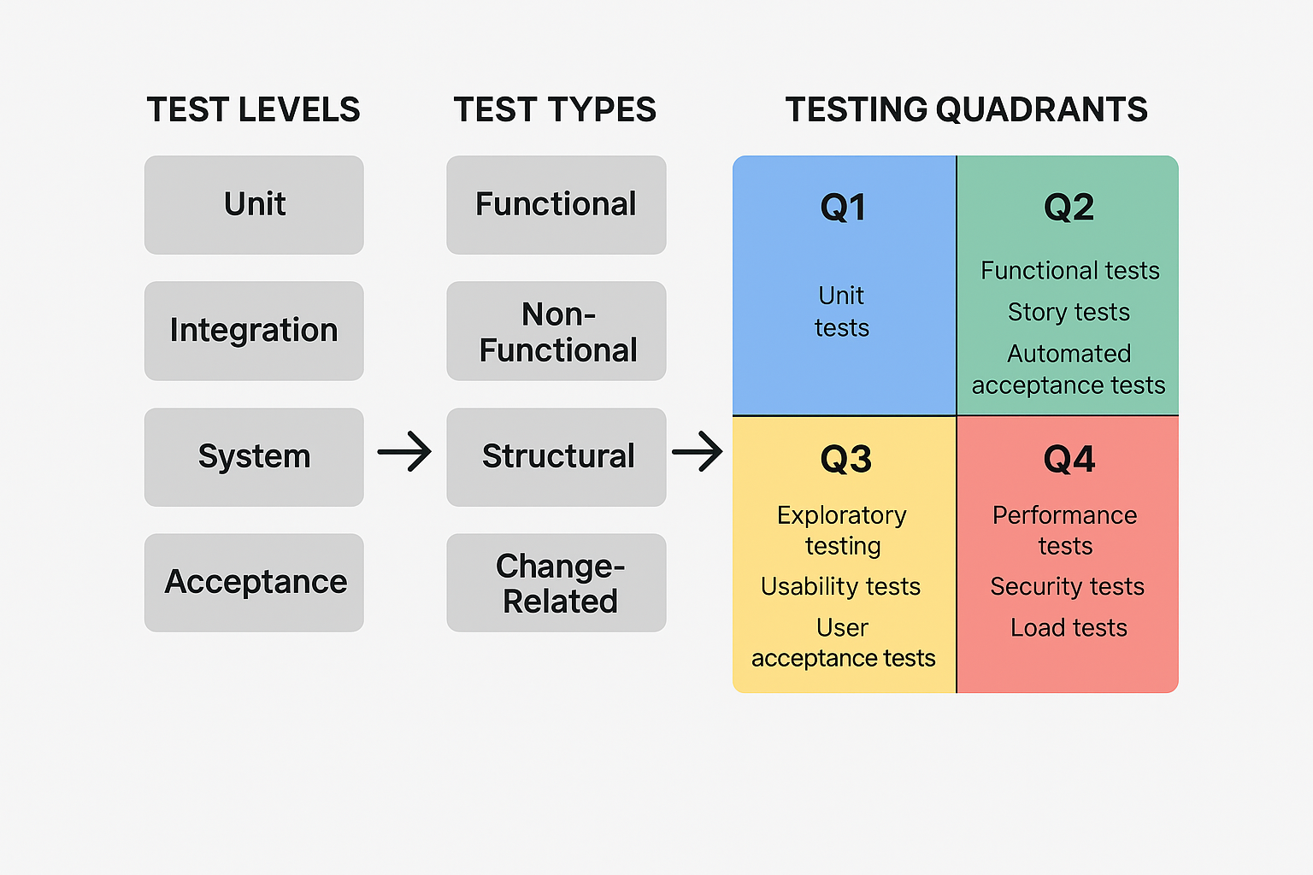

✅ Summary
# Source: AI Source: Provided by: [Data Path: Persons Table -> ID Column: 1, Name_En Column: Motasem Essam] -> From: [ChatGPT] on [8/21/2025]
- Test Levels = Where in the lifecycle
- Test Types = What aspect is tested
- Testing Quadrants = A planning tool to balance business & technology focus across test types

📌 Visual Summary
# Source: AI Source: Provided by: [Data Path: Persons Table -> ID Column: 1, Name_En Column: Motasem Essam] -> From: [ChatGPT] on [8/21/2025]
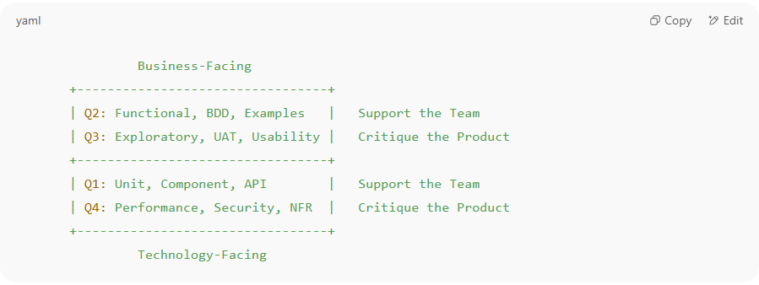
Business-Facing
+---------------------------------+
| Q2: Functional, BDD, Examples | Support the Team
| Q3: Exploratory, UAT, Usability | Critique the Product
+---------------------------------+
| Q1: Unit, Component, API | Support the Team
| Q4: Performance, Security, NFR | Critique the Product
+---------------------------------+
Technology-Facing

✅ In short:
# Source: AI Source: Provided by: [Data Path: Persons Table -> ID Column: 1, Name_En Column: Motasem Essam] -> From: [ChatGPT] on [8/21/2025]
- Q1 & Q2 → Help the team build the right product (preventing defects).
- Q3 & Q4 → Help the team evaluate the product (finding defects, risks).
- Together, the quadrants ensure both functional & non-functional quality.

